**COVID-19 Detection using Cough Recordings**

Project-I (18ME10024) report submitted to

Indian Institute of Technology, Kharagpur

In partial fulfillment for the award of the degree of

Bachelor of Technology (Hons.)

In

Mechanical Engineering

**By**

**Himanshu**

**(**18ME10024**)**

**Under the supervision of**

**Prof. Ram Babu Roy**



**Department of Mechanical Engineering**

**Indian Institute of Technology, Kharagpur**

**Autumn Semester,**

**November 22, 2021**

**DECLARATION**

I certify that

(a) The work contained in this report has been done by me under the guidance of my supervisor.

(b) The work has not been submitted to any other Institute for any degree or diploma.

(c) I have conformed to the norms and guidelines given in the Ethical Code of Conduct of the Institute.

(d) Whenever I have used materials (data, theoretical analysis, figures, and text) from other sources, I have given due credit to them by citing them in the text of the thesis and giving their details in the references. Further, I have taken permission from the copyright owners of the sources, whenever necessary.

Date: Himanshu

Place: IIT Kharagpur (18ME10024)



**DEPARTMENT OF INDUSTRIAL ENGINEERING**

**INDIAN INSTITUTE OF THECHNOLOGY, KHARAGPUR**

**KHARAGPUR-721302, INDIA**

***CERTIFICATE***

This is to certify that the project report entitled **“COVID-19**”** submitted by Himanshu (Roll No. 18ME10024) to Indian Institute of Technology, Kharagpur towards fulfillment of requirements for the award of degree of Bachelor of Technology (Hons.) in Mechanical Engineering is a record of bonafide work carried out by him/her under my/our supervision and guidance during Autumn Semester 2021-22.

**Prof. Ram Babu Roy**

**Rajendra Mishra School of Engineering Entrepreneurship**

**Indian Institute of Technology**

**Kharagpur, India**

**Date –**

**Place- IIT Kharagpur**

# Table of Index

## Abstract

## Introduction

## Literature Review

## Problem Definition

## Solution Methodology

## Data generation and Numerical Experiment

## Results and Sensitivity Analysis

## Conclusion and Future work

## References

# Abstract

COVID-19 continues to be a global pandemic, and much technological intervention is already in place to identify COVID-19 patients. The paper focuses on the contactless detection of COVID-19 patients by analyzing their audio cough samples. The report demonstrates five machine learning classification models and combines those models into an ensemble model with 26 dominant features. The initial results will be forming part of a larger project of developing suitable interfaces. Such devices can reduce the workload on frontline workers and provide an efficient way to manage the resources and time of healthcare professionals. The proposed method has been tested on cough audios, both COVID-19 positive and healthy individuals. The results are promising, scoring accuracy of 99.3% and sensitivity of 99% on validation data, all while maintaining interpretability.

# Introduction

The absolute aim of supply chain management is to increase the efficiency and effectiveness of delivering products to customers while bearing minimal costs to the manufacturer. Effective pragmatic modelling of these supply chains is the essential for every company to strive in the cutthroat economy. The modelling of supply chain changes depends on factors like demand scenario of the product, customer market, resources availability, manufacturing technology. With the advent of Additive manufacturing (AM) technology both the cost and time of manufacturing small to medium sized products is decreasing over time. Additive manufacturing is an official industry standard term (ASTM F2792-12a) defined as the process by which 3D model data is used to build an object by material deposition in layers as opposed to subtractive manufacturing technologies. Also, the usage of different type of material other than plastics and metals like ceramics, composites and graded/hybrid metals is often seen nowadays. Manufacturing firms are moving towards producing low volume, innovative and highly customised products with high added value thanks to the AM techniques which can provide designers additional freedom which earlier was not accompanying with traditional manufacturing methods. Since Additive manufacturing is still an emerging technology and is not yet commercialised on large scale, the application of Additive manufacturing in supply chain is still limited to some parts of the main product which are then assembled together or in assisting conventional manufacturing technologies. For example, it is used for optimizing injection moulding and die casting operations by integration of cooling channels and mould inserts, tempering channels in tools used in die casting which can be directly manufactured through additive manufacturing. [EOS} But accessing these indirect impacts of additive manufacturing by significantly reducing the cycle time in some operations of a conventional manufacturing assembly process is challenging and complex to model. Also, currently due to high costs of Additive manufacturing machinery and high operating costs (due to post processing activities because of inferior surface finish and tolerances by additive manufacturing) are major challenges for small and medium scale industries to adopt additive manufacturing in complete manufacturing of products. Thus, the need for outsourcing additive manufacturing parts is expressed by many industries which brings into picture the requirement of make to order industries which can supply the parts based on design specifications given by the customer.

This paper aims to provide a supply chain model for industries producing on order manufacturing which will determine the optimal number and location of additive manufacturing hubs that needed to be setup by a manufacturing company having conventional manufacturing facilities already setup based on an uncertain demand with capacity constraints to minimize its cost of production. The problem considers both location and capacity (number of additive manufacturing machines) of each additive manufacturing hub to be setup. Finally, a sensitivity analysis is performed on growing demand of additive manufacturing products, decrease in the setup cost as well as production cost of additive manufacturing.

# Literature Review

Additive manufacturing, also known as direct manufacturing or three-dimensional printing, is a digital technology for producing physical objects layer by layer from a three-dimensional (3D) computer aided design (CAD) file [1] rather than through moulding or subtractive techniques (such as machining). A variety of materials can be processed additively including polymers, metals, ceramics, electronic materials, and biological materials [2]. Many papers have been written on the cost of particular additive manufacturing process, its optimization and about post processing schemes [3]. Currently, all metal AM methods to obtain the final part geometric dimensions require some form of post-processing, surface finish, and material properties. Additive and subtractive machining can occur in the same machine envelope with the directed energy deposition. However, the clear majority of AM metal processing occurs in a dedicated additive manufacturing build envelope.

The recent emergence of AM emerged as one of the most important disruptive technologies can be attributed to the continuous stream of AM supply chain research. Accordingly, several researchers have investigated the introduction of AM in supply chains from various perspectives, such as [4], [5], [6] ,[7]. Spare parts supply chain management attempts to reduce operating costs while keeping the customers’ satisfaction at an acceptable level [8]. It is shown above that several studies have been conducted investigating the application of AM in the context of spare parts supply chains. However, because AM technology is constantly evolving, the conclusions should be revisited periodically, and a step-by-step procedure must be used to determine AM’s suitable applications [6]. Most of these studies qualitatively imply that the spare parts supply chain adopting AM is supposed to be superior to a conventional one, but this comparison lacks the research to quantitatively verify using a supply chain model the positive implications of AM on a spare parts supply chain. Thus, a study that considers all the important parameters like production cost ratio of AM to CM, uncertainty in demand of AM and CM made products, inventory and transportation costs needed to be done by developing a MIP model that describes the problem aptly and approaches the challenge of adoption of AM into the existing supply chain.

# Problem definition

In this paper we consider a problem of finding out optimal number of Additive manufacturing hubs to be setup based on uncertain demand and having constraints on production capacity, availability of machine due to maintenance and scheduling efficiency. The production is assumed to take place in fix time period. This paper aims to provide a supply chain model for industries producing on order manufacturing. These industries usually do not have to keep inventory of the products as the design and material specifications of product to be made are unknown to the manufacturer until the order by the customer firm is received by the manufacturer. This model will have application in the spare part industries, automobile industry, aircraft manufacturing etc. In this model, we consider an uncertain demand-based production supply chain in which all the orders in each period i.e. in our case consider to be four months are placed at the start of the period and we aim to find optimal number of additive manufacturing hubs that should be setup. The setup cost of the additive manufacturing hub can be computed for the given period by dividing the total setup cost by the total useful life of an AM setup and multiplying it with number of days considered in the period.

# Formulation

A model for optimized prediction of additive manufacturing facilities that a manufacturing company needs to set up to increase its profits. We assume that there are pre-setup conventional manufacturing facilities at different distribution centers. The question now arises is that how much capacity of AM facility needs to be setup at each distribution centre to maximize the returns to the company. The constraints in this optimization problem are the capacity of AM and CM manufacturing facilities respectively, the availability time of these machines due to regular repair and maintenance of machines due to possible faults in the machines.

The total cost of production consists of the fixed or setup cost of the additive hubs, the production costs and the transportation costs. The other costs like inventory costs, material procurement costs are included in the production cost for simplicity. Although many other benefits of this manufacturing model like shorter lead time, reduction in carbon emissions due to reduction in transportation costs, efficient designs for products could not be modelled. The first part of the cost function $F∙\sum_{l=1}^{l=\left|L\right|}{Z_{l}}$ represents the fixed cost incurred per year in setting up and running the Additive manufacturing facility (AMF). This is the first stage decision and independent of all the generated scenarios in the Sample Average Approximation method applied which is explained later in this paper. The second term in the cost function represents the second stage costs which are dependent on the scenarios generated. Here the first stage variables are the decisions which are taken before the scenarios are realized while second stage decisions are different for each scenario and are taken as corrective or recourse actions after the scenario is realised. The first and second terms of second stage cost represent the production cost of products manufactured by CM, production cost of products manufactured using AM (including the post processing cost needed) respectively and the last term represents the transportation cost from distribution centres to the customer. The first constraint equates the total number of products made by both CM and AM to the demand of that product. Constraint 2 is used for stating the limited capacity of conventional manufacturing. The production time of all the products made using a machine of type $j$ at the distribution centre $l$ is thus made less than or equal to the total available time on the machine $j$. The third constraint specifies that the summation of number of parts made using additive manufacturing from all the L distribution centres in the scenario $ω$ is equal to the total number of parts made using additive manufacturing in scenario $ω$ given by the term ${{typ}_{2_{i}}∙P}_{iω}$. Similarly, in constraint 4 we consider that the summation of number of parts made using conventional manufacturing from all the L distribution centres in the scenario $ω$ and equate it to the total number of parts made using additive manufacturing in scenario $ω$ given by the term ${typ}_{1}∙Q_{iω}$. In the fifth constraint the production time of additive manufacturing parts made in distribution centre $l$ (which includes the time needed for post processing of the part) to be less than the total availability time of additive manufacturing facility in the distribution centre $l$ during the considered three-month period. The total availability time of additive manufacturing facility in the distribution centre $l$ during can be given by the term $T^{'}{∙Z}_{l}$. Lastly, we specify bounds on our variables $Q_{iω} , P_{iω}$ (i.e. quantity of product type $i$ that is made by CM in $ω$ replication and quantity of product type $i$ made by AM in $ω$ replication respectively) to be real positive numbers, while number of AM machines in distribution center $l$ is an positive integer. The variables $x_{ilω}$ and $y_{ilω}$ (i.e. number of products $i$ made using AM in distribution center $l$ in $ω$ replication and number of products $i$ made using CM in distribution center $l$ in $ω$ replication respectively) are specified to be binary numbers.

## Model

N = set of customers (each having different product)

L = set of distribution centers

M = set of machines types

## Indices

$i$ = index of product

j = index of machine type

$l$ = index of distribution centers

## Parameters

${Dist}_{il}$ = the distance between customer $i$ and distribution center $l$.

$D_{iω}$ = order / demand of the product $i$

$R_{i}$ = routing of a product $i$ in CM. (ie machine type 1,3,2 or 1,3,4)

$N_{jl}$ = number of machines of type j at distribution center $l$

$t_{ij}$ = the processing time of product $i$ on machine j (including the individual setup time)

$t_{i}^{'}$ = the processing time of product $i$ on AM machine (including the individual setup time)

$T_{j}$ = the total availability time of machine j during the period considered

$T^{'}$ = the total availability time of each AM machine during the period considered

$S_{ij}$ = the setup time of product type $i$ on machine j

F = cost of setting up an AMF

$C_{i}$ = per unit cost of manufacturing product $i$ on CM

${Cp}_{i}$ = per unit cost of manufacturing product $i$ on AM

$C_{T_{i}}$ = transportation costs per unit product per unit distance.

$a_{ij}$ = 1 if machine type j is used for product $i$

0 otherwise

### Stage 1 variables

$Z_{l}$ = number of AM machines in distribution center $l$

### Stage 2 Variables

$Q_{iω}$ = Quantity of product type $i$ that is made by CM in $ω$ replication

$P_{iω}$ = Quantity of product type $i$ made by AM in $ω$ replication

$x_{ilω}$ = number of products $i$ made using AM in distribution center $l$ in $ω$ replication

$y_{ilω}$ = number of products $i$ made using CM in distribution center $l$ in $ω$ replication

$$Min: Cost=F∙\sum_{l=1}^{l=\left|L\right|}{Z_{l}} + E\left(Q\left(x\right)\right)$$

$$where$$

$$E\left(g\left(x\right)\right)=\min{\frac{1}{\left|Ω\right|}\sum_{ωϵΩ}{\left(\sum_{i=1}^{i=|N|}{C_{i}∙Q_{iω}+ \sum_{i=1}^{i=|N|}{{Cp}_{i}∙}P_{iω}+\sum_{i=1}^{i=|N|}{C_{T_{i}}}∙\left(\sum_{l=1}^{l=|L|}{\left[{Dist}_{il}\right]∙{(x}_{ilω}}+y_{ilω})\right) }\right)} }$$

s.t

${{typ}_{1_{i}}∙Q}_{iω} + {typ}_{2_{i}}∙P_{iω}= D_{iω }∀ i ∈N, ω∈W$

$\sum_{i=1}^{i=|N|}{a_{ij}∙t_{ij }∙y_{jlω }}≤ N_{jl}∙T_{j}-\sum_{i=1}^{i=\left|N\right|}{a_{ij}∙S_{ij }} ∀ l ∈L,j ∈M, ω∈W$

$\sum_{l=1}^{l=|L|}{x_{ilω}}= {{typ}_{2_{i}}∙P}_{iω} ∀ i ∈N, ω∈W$

$\sum_{l=1}^{l=|L|}{y_{ilω}}= {typ}_{1}∙Q_{iω} ∀ i ∈N, ω∈W$

$\sum_{i=1}^{i=|N|}{{t_{i}^{'}∙x}_{ilω}}≤T^{'}{∙Z}_{l}$ $∀ l ∈L, ω∈W$

4. $Q_{iω} , P_{iω}$ > 0, $∈R$
$Z_{l}∈Z$

5. $x_{ilω}$, $y_{ilω }∈\{ 0, 1 \}$

# Solution Methodology

A Monte Carlo simulation–based approaches are used to stochastic discrete optimization problems. The basic idea of such methods is that a random sample is generated, and the expected value function is approximated by the corresponding sample average function. The obtained sample average optimization problem is solved, and the procedure is repeated several times until a stopping criterion is satisfied.

In this study we have used the Sample Average Approximation (SAA) method. It is a common method to solve stochastic problems, where the average value obtained for a very large sample of s scenarios is used to approximate the true expected value of the objective function. In this method generates M separate sample sets $Ω_{m}$,where m ∈ {1,2, 3. . ., M}, each one containing N scenarios generated from N different i.i.d. (Independent and identically distributed) demand vectors ( $ω_{j}^{1}…..ω_{j}^{N})$ following a probability distribution. For each one of the scenarios set, $Ω_{m}$, the resulting SAA problem (where Ω is replaced by $Ω_{m}$ in model) is solved generating a candidate solution. Then, for each candidate solution, the first-stage solution is fixed, and the value of the objective function for a very large sample with s scenarios is computed. In the case of the two-stage optimization model, this value is computed by solving a pure linear programming problem on the second-stage variables.

A sample $ξ_{1}$,…, $ξ_{N}$ of N realizations of the random vector ξ(ω) is generated.

For example, consider in [9] they performed some theoretical studies on performance of sample average approximation method for solving stochastic discrete optimization problems. It was shown that as the sample size N increases

the probability that a replication of the SAA method produces an optimal solution increases exponentially.

For any two-stage stochastic programming problem

$$\min{Z= c^{T}x+ Ε(Q\left(x,ω\right))}$$

$$s.t. Ax=B$$

$$x≥0$$

Where $Q(x,ω) = min q(ω)ty(ω)$

$$s.t. W(ω)y(ω) = h(ω) – T(ω)x$$

$$y(ω) ≥ 0$$

Here $x ∈R_{n}$ is the first-stage decision vector, $X$ is a polyhedral set, defined by a finite number of linear constraints, $y ∈R_{m}$ is the second-stage decision vector and $ξ = (q, T,W, h)$ contains the data of the second-stage problem. In this formulation, at the first stage we must make a “here-and-now” decision x before the realization of the uncertain data $ξ$, viewed as a random vector, is known. At the second stage, after a realization of $ξ$ becomes available, we optimize our behavior by solving an appropriate optimization problem. At the first stage we optimize (minimize) the cost $c^{T}x$ of the first-stage decision plus the expected cost of the (optimal) second-stage decision. We can view the second-stage problem simply as an optimization problem which describes our supposedly optimal behavior when the uncertain data is revealed, or we can consider its solution as a recourse action where the term $Wy$ compensates for a possible inconsistency of the system $Tx ≤ h$ and $q^{T}y$ is the cost of this recourse action. $Ε\left(Q\left(x,ω\right)\right)$ is the expected recourse function gives the expected cost of the optimal second-stage decision given first-stage decision x.

We now turn our attention to approaches that reduce the scenario set to a manageable size by using Monte Carlo simulation. That is, suppose that the total number of scenarios is very large or even infinite. Suppose, further, that we can generate a sample $ξ_{1}$, ..., $ξ_{N}$ of N replications of the random vector $ξ$. By this we mean that each $ξ_{j}$, j = 1, ..., N, has the same probability distribution as $ξ$. Moreover, if $ξ_{j}$ are distributed independently of each other, it is said that the sample is i.i.d. (independent identically distributed). Given a sample, we can

approximate the expectation function $q(x) = E[Q(x,ξ)]$ also called as the “true” problem by the sample average function $q_{N}\left(x\right)$ which will be called as the SAA problem henceforth in this paper. [TUTORIAL SP]

$$q_{N}\left(x\right)=\frac{1}{N}∙\sum_{n=1}^{n=N}{Q(x,ξ)}$$

Let $υ^{N}$ and $x^{N}$ denote the optimal value and the optimal solution of the SAA problem, respectively while, $υ^{*}$ and $x^{*}$ denote the optimal value and the optimal solution of the true problem, respectively. The important question that arises here is whether $υ^{N}$ and $x^{N}$ converge to their true counterparts $υ^{*}$ and $x^{*}$ It has been shown in a study that a solution to the SAA problem converges to a solution of the true problem as N $→$ ∞ [10].In another study [11] and later [9] proved that for SLPs with discrete distributions, an optimal solution of the SAA problem provides an exact optimal solution of the true problem with probability approaching one exponentially fast as N increases. We also consider sets of $ε$-optimal solutions. That is, for $ε ≥ 0$, we say that $x$ is an ε-optimal solution of the true problem $q(x)$ if ¯x ∈ S and $q(x)$ ≤ v∗ +ε. The sets of all ε-optimal solutions of $q(x)$ and $q_{N}\left(x\right)$ are denoted by $S^{ε}$ and $S_{N}^{ε}$, respectively. Clearly for ε = 0 set $S^{ε}$ coincides with $S^{*},$ and $S_{N}^{ε}$ coincides with $S_{N}$.

## SAA Algorithm Design

Although theoretical bounds exist on the sample size required to find an ε-optimal solution with probability at least 1−α as shown in [9], they are usually hard to compute and far too conservative to obtain a practical estimate. Therefore, the choice of sample size N may be adjusted dynamically, depending on the results of preliminary computations. The trade-off between the quality of an optimal solution of the SAA problem, and the bounds on the optimality gap on the one hand, and computational effort on the other hand, should be considered.

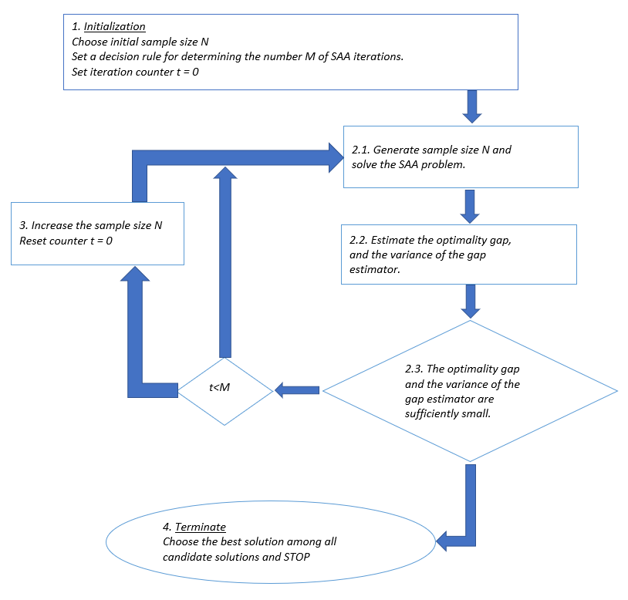

Figure 1. Sample Average Approximation Algorithm Flow Chart

# Data generation and Numerical Experiment

As additive manufacturing is an emerging technology it still does not have its roots in supply chain of many manufacturing industries. Thus, the data required for modelling the complete supply chain consisting of both additive manufacturing and conventional manufacturing could not be directly taken from experimental values. Thus, in this experiment we generate data resembling the costs, time and requirements in the real world. Due to long computational times of the experiments conducted we have considered a small-scale dataset.

In this study we have considered 4 distribution centres of manufacturer supplying orders of 10 customers in a period of 3 months. The locations of these customer and distribution centres are generated randomly. For assigning the operations sequence on each part on conventional manufacturing machines [12] has been referred. For each 10 parts a different sequence of operation is generated from 5 types of conventional machines. Each distribution centre is considered to have a limited capacity of these conventional manufacturing machines given by $N_{jl}$. Further the processing time and cost of products are generated after considering results from [markforged.com] which are summarised in table below. A sensitivity analysis is performed at the end of this study to determine the effect of increase in ratio of average production cost of CM/AM and the decrease in production time of AM with innovation in additive manufacturing technology. The availability time which is dependent upon the time required for maintenance is assumed to be 2600 hrs for CM and 150 per machine for AM for the uncertain demand for each customer is generated from a normal distribution with mean 75 and variance 10. The setup costs for additive manufacturing is considered from the analysis conducted by [13] summarised in table 2.

Table 1. Comparison of production cost and time per unit manufactured by CM and AM [by markforged]

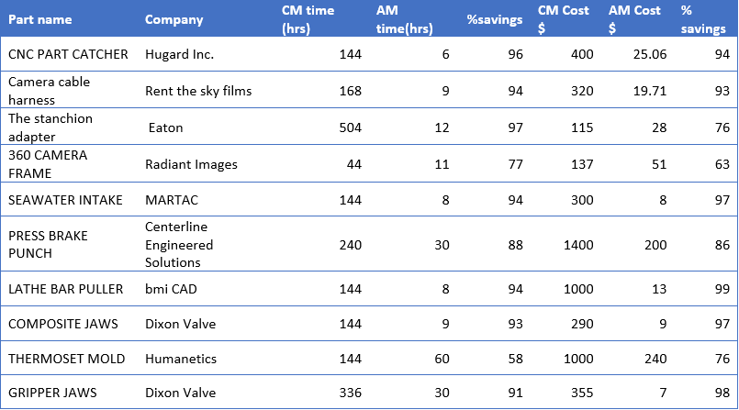

Table 2. AM setup cost built-up

|  |  |  |
| --- | --- | --- |
| **Fixed Cost** | **Cost/Year (USD)** | **Source** |
| Machine Depreciation | $97,702 | [5];[14]; |
| Rent | $34,170 | [15] |
| Utilities | $12,562 | [5] |
| Technician Salary | $26,732 |  |
| Indirect Cost/Machine hr | $223,104 |  |
| Indirect Consumables | $1,540 | [15] |
| Indirect Software Cost | $462 | [5];[14] |
| Indirect Hardware Cost | $462 | [5];[14] |
| Machine Software Cost | $3,081 | Machine Costs |
| Machine Hardware Cost | $924 |  |
| Machine Maintenance | $23,104 | [15] |
| Direct Machine Consumables | $2,700 | [5] |
| Total Fixed Cost | $340,335 |  |

The total setup cost in [13] was calculated per year thus we reduce it and calculate for 3 months. The number of scenarios to be generated to achieve convergence and the desired optimality gap was calculated to be 250 with 50 replications of the SAA problem.

# Results and Sensitivity Analysis.

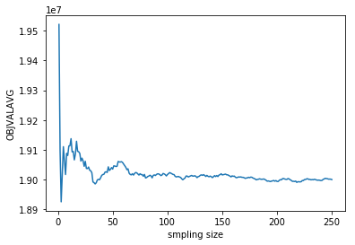The SAA optimization problem is coded using python and optimization was done using a solver Gurobi using an Intel® Core™ i5-6300HQ CPU @2.30 GHz, 4 Cores with 8.00 GB of RAM. The convergence was seen clearly in the graph of sample average approximation of the optimal value vs the number of samples considered. The convergence was tested considering initial sample size as 50 and with 50 repetitions of the SAA problem. The sample size was increased with an increment of 10. Satisfactory convergence results were found when sample size was greater than 200. For large dataset this size will increase thus seeing this fact we consider a sample size for 250 for obtaining the further results. The sensitivity analysis results generated for the data set consider are given below in a typical setting of parameters. These results show a considerable variation when a sensitivity analysis was performed on the parameters. The parameters considered in the sensitivity analysis were the average demand of products, setup cost

Figure 2. Convergence of SAA algorithm shown by plot of Average objective function value vs sample size

of additive manufacturing. These parameters were primarily considered because the effect of these parameters affect the total cost the most

.

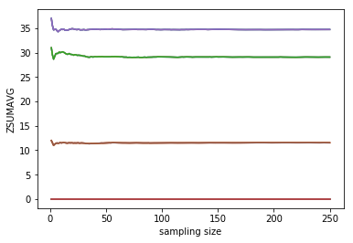

Figure 3. Optimal number of AMF ${(Z}_{l})$ at distribution centre $l$

##### Conclusion and future work

This paper provides a novel approach for integration of additive manufacturing with conventional manufacturing in the manufacturing supply chain. The model used in this paper sets the base for future supply chain models for small and medium scale industries to integrate additive manufacturing facility in their already running conventional manufacturing facility. Due to lack of exact dataset of additive manufacturing production costs and time for different products and on the demand of products made using additive manufacturing and their uncertainty in the market it is difficult to get results which can gather true profit engaging insights. Due to same reasons the sensitivity analysis could be performed only on two important factors. In future studies some other parameters like average demand of products that can be made using additive manufacturing only, the average ratio of production cost of additive manufacturing and conventional manufacturing, number of distribution centres can be considered in the study. But without exact industrial datasets on these parameters, the study of these parameters in sensitivity analysis is not convincible. The sensitivity analysis on number of distribution centres can be done but will need more computational capacity to compute the results in some feasible time. Also, on similar lines one can develop a model which can deal with additive manufacturing supply decisions on a real time basis.

Table 3. Sensitivity Analysis of Average Demand

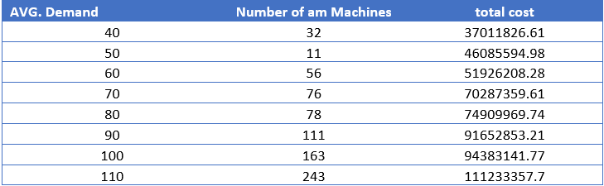

Figure 4. Sensitivity analysis of Average Demand

Table 4. Sensitivity analysis on AMF setup cost

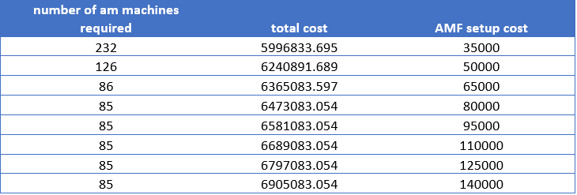

Figure 5. Sensitivity analysis on AMF setup cost

# References

[1] I. Flores Ituarte, J. Partanen, and S. H. Khajavi, “Challenges to implementing additive manufacturing in globalised production environments,” *Int. J. Collab. Enterp.*, 2016.

[2] I. Gibson, D. W. Rosen, and B. Stucker, “Chapter 14 - Direct Digital Manufacturing,” in *Additive Manufacturing Technologies*, 2010.

[3] M. Schröder, B. Falk, and R. Schmitt, “Evaluation of cost structures of additive manufacturing processes using a new business model,” in *Procedia CIRP*, 2015.

[4] T. Birtchnell and J. Urry, “3D, SF and the future,” *Futures*, 2013.

[5] M. Baumers, P. Dickens, C. Tuck, and R. Hague, “The cost of additive manufacturing: Machine productivity, economies of scale and technology-push,” *Technol. Forecast. Soc. Change*, 2016.

[6] S. H. Huang, P. Liu, A. Mokasdar, and L. Hou, “Additive manufacturing and its societal impact: A literature review,” *International Journal of Advanced Manufacturing Technology*. 2013.

[7] M. Gebler, A. J. M. Schoot Uiterkamp, and C. Visser, “A global sustainability perspective on 3D printing technologies,” *Energy Policy*, 2014.

[8] Y. Li, G. Jia, Y. Cheng, and Y. Hu, “Additive manufacturing technology in spare parts supply chain: a comparative study,” *Int. J. Prod. Res.*, 2017.

[9] A. J. Kleywegt, A. Shapiro, and T. Homem-de-Mello, “Sample Average Approximation Method for Stochastic Discrete Optimization,” *SIAM J. Optim.*, 2002.

[10] R. Schultz, L. Stougie, and M. H. Van Der Vlerk, “Two-stage stochastic integer programming: A survey,” *Statistica Neerlandica*. 1996.

[11] A. Shapiro and T. Homem-de-Mello, “A simulation-based approach to two-stage stochastic programming with recourse,” *Math. Program. Ser. B*, 1998.

[12] E. M. Wicks and R. J. Reasor, “Designing cellular manufacturing systems with dynamic part populations,” *IIE Trans. (Institute Ind. Eng.*, 1999.

[13] D. Strong, M. Kay, B. Conner, T. Wakefield, and G. Manogharan, “Hybrid manufacturing – integrating traditional manufacturers with additive manufacturing (AM) supply chain,” *Addit. Manuf.*, 2018.

[14] C. Lindemann, U. Jahnke, M. Moi, and R. Koch, “Analyzing product lifecycle costs for a better understanding of cost drivers in additive manufacturing,” *Int. Solid Free. Fabr. Symp.*, 2012.

[15] D. Thomas, “Costs, benefits, and adoption of additive manufacturing: a supply chain perspective,” *Int. J. Adv. Manuf. Technol.*, 2016.